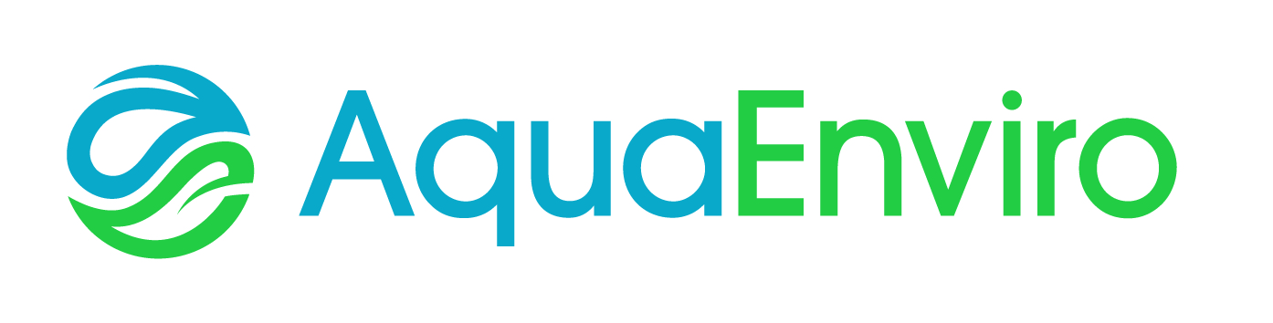

12th European Waste Water Management Conference & Exhibition
17th and 18th July 2018, Manchester United Football Stadium, UK

Exhibition & Marketing Booking Form
The exhibition fee includes:
- Stand space - 3m in length by 2m depth
- Power supply
- One person to man the stand, including refreshments.
- Exhibiting companies will be listed on the conference website, programme handed to delegates on site and conference app.

Optional extras:
- Exhibitors are not automatically registered to attend the conference; however, they are entitled to 20% off the delegate rate. Fees are detailed below.
- Conference Dinner on Tuesday 17th July - £50 per ticket

Please note that stands will be allocated on a first come, first served basis. You will be sent information on access and set-up approximately one month before the date of the conference.

Company Name:

Company Address:

Contact for all Correspondence: | Name: | Tel:
 | Email:

Fees (All prices exclude VAT @ 20%) |  |  | Rate  (exc. VAT) | Quantity
Exhibition Space Includes 1 person to man the stand for 2 days |  |  | £995

Name, Job Title and Email Address of person manning the stand

Additional person(s) manning the stand (2-day rate) |  |  | £100

Name, Job Title and Email Address of person (s) manning the stand

Conference Registration
(The price below includes a 20% discount off standard rates for exhibiting companies)
Full Delegate (Standard fee £550) |  |  | £440
Water Companies / Young Professionals (Standard Fee £395) |  |  | £316
Author/Speaker (Standard fee £395) |  |  | £316
Students, Academics & Charities (Standard Fee £200) |  |  | £160
Conference Dinner – 3 courses and wine |  |  | £50
Name (s) | Job Title (s) | Email Address (s) |  | Rate (as above)

Advertising Opportunities
Insert in Delegate Packs  (1-page flyer (2 printed pages) or promotional item i.e. pen) | £350
Full page advert in programme | £295
½ page advert in programme | £225
Button advert with link on the www.ewwmconference.com website (until the conference date) | £350
TOTAL PAYABLE | Exc. VAT | Inc. VAT @ 20%
 | £ | £

Method of Payment

INVOICE: Please invoice the sum of £___________________ PO Number: _______________________

Invoicing Address (If different from above): __________________________________________________________________________________________________________________________________________________________________________________________________________________________________________________________________________________________

Purchase Orders should be made out to:

SUEZ Advanced Solutions UK Ltd
290 Aztec West
Bristol,
BS32 4SY
Registered Company No. 5687775
VAT No. GB108298209
Account Number: 21391181
Sort Code: 56-00-05

CREDIT / DEBIT CARD: To pay by credit card please call the office on 01924 257 891

Exhibition Booking & Payment Terms & Conditions:
Booked exhibitor space may be cancelled, with no penalty, within 30 calendar days of Aqua Enviro receiving the completed booking form. If the request for cancellation is received later than 30 calendar days of booking, the exhibitor will be required to pay 100% of the fee.
If the conference/event is cancelled for whatever reason, exhibitor fees paid will be refunded in full. However please note any associated hotel or travel expenses incurred by exhibitors will not be refunded.
Please note by signing this booking form you agree to the above terms and conditions.

Signed | Print Name:

Please save and the send this completed form to:

Sarah Brown: Fax (44) 01924 257 455, e.sarah.brown@aquaenviro.co.uk

